Python Assessment -8 - 20-12-23

Topics covered:

* Json
* Numpy module

Json:

Json is known as java script object notation. In this the entire data is in the form of objects.

We used json python module to convert the json data into python dictionary.

**Converting json string to python dictionary**

**Json.loads() :** It loads and parse the json string type.

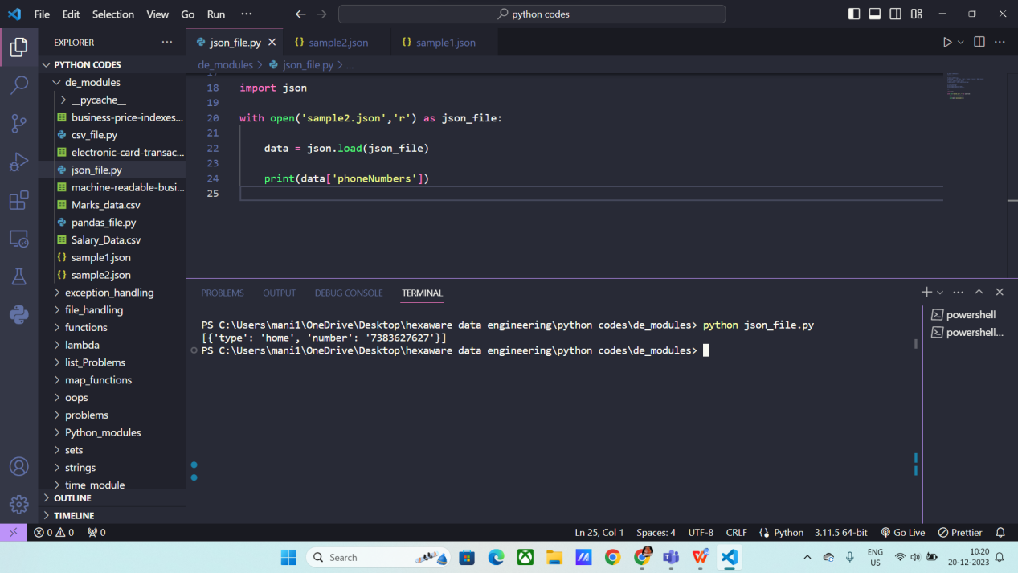

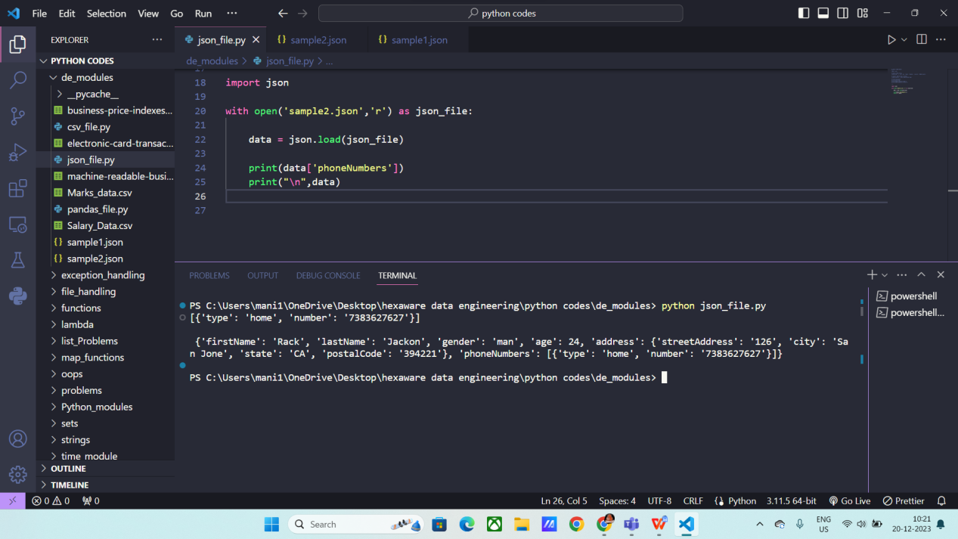

**Converting json object into dictionary:**

**Json.load:** used to parse json objects.

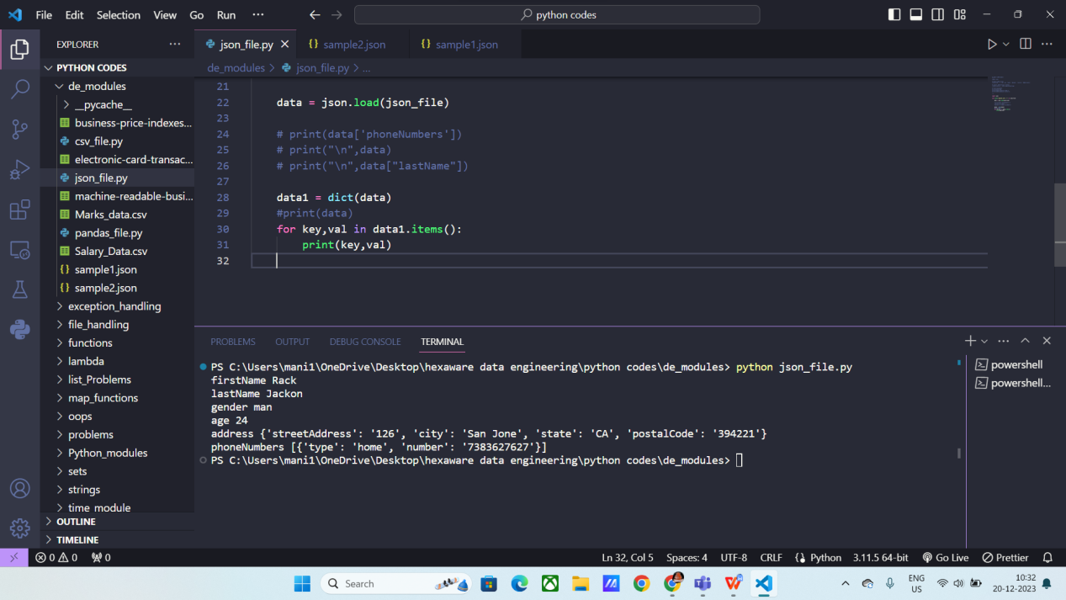

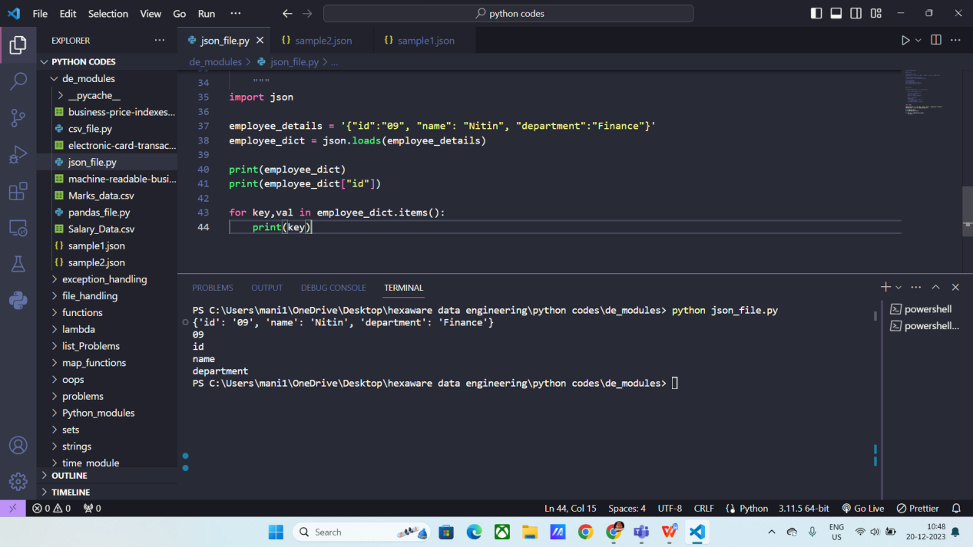

**Program to convert python dictionary to json file:**

Here we used json.dump() method to convert into json object.

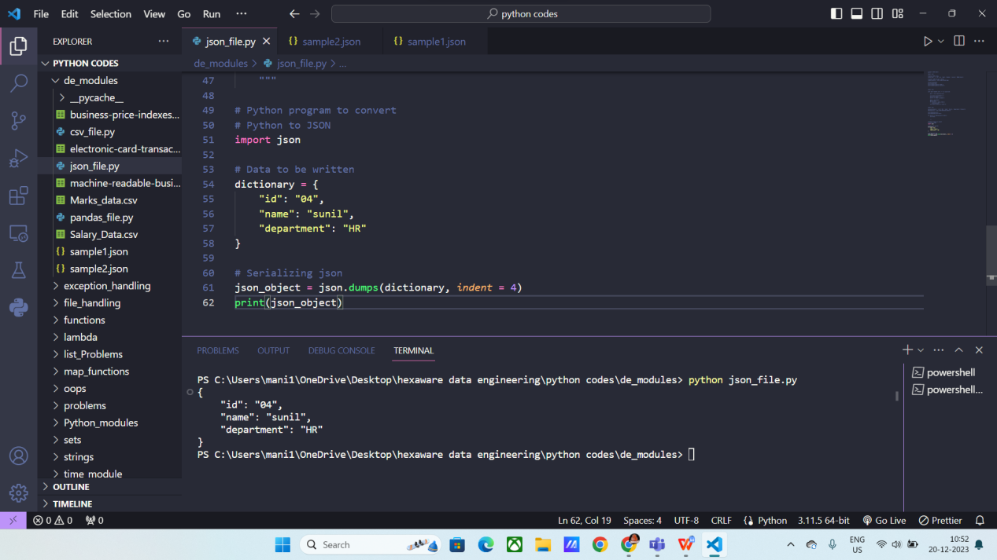

**Writing json into a file using python**

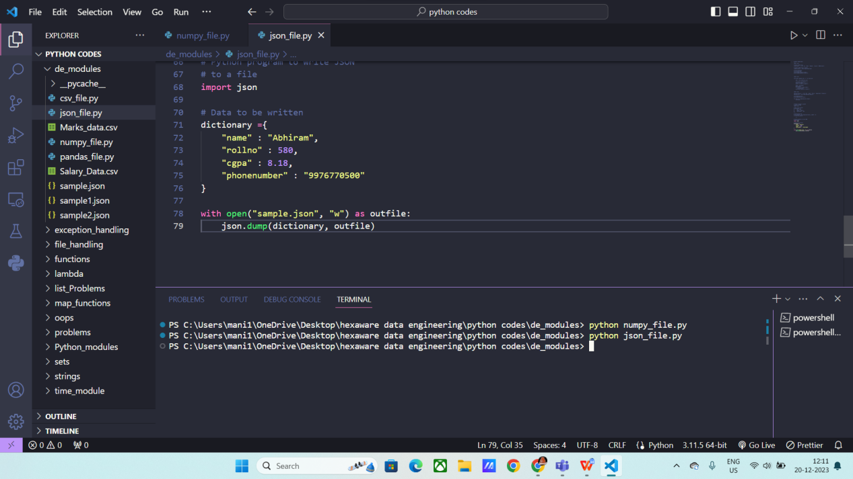

**Numpy methods :**

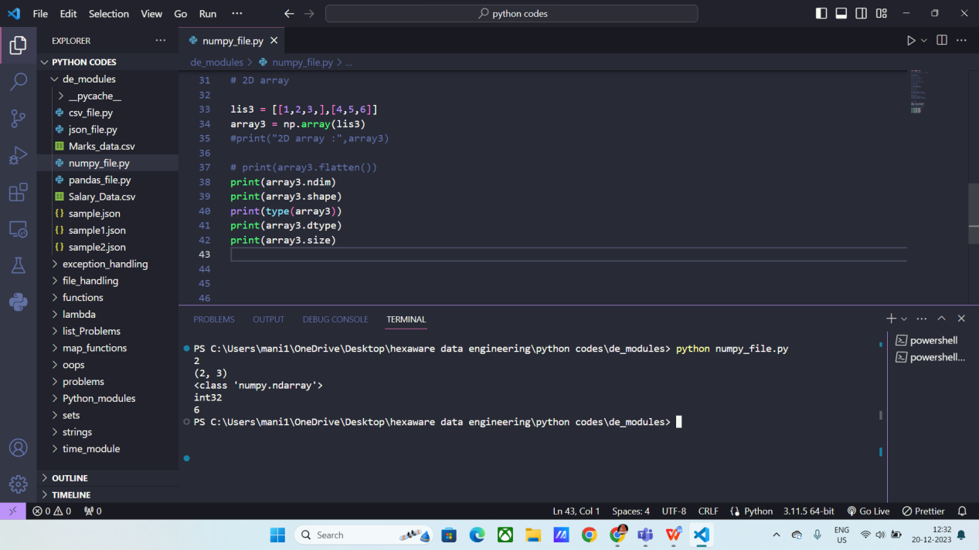

**Numpy array creation :**

* Array()
* Built-in methods :

Np.zeros()

Np.ones()

Np.random.random()

Np.full()

* Np.arange()
* Np.linespace()

